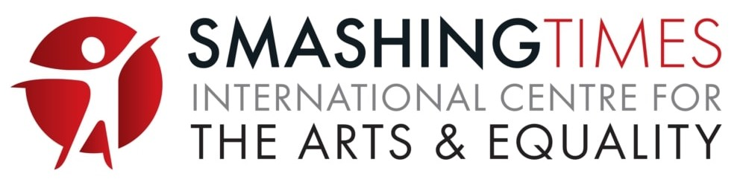
Smashing Times International Centre for the Arts and Equality

Kerry Arts and Human Rights Festival
Where storytelling, human rights + fun connect
Cahersiveen and Valentia Island, County Kerry
18 + 19 July 2026
Book Here or Tickets at Door
Info: Freda 087 2214245 or email admin@smashingtimes.ie
www.smashingtimes.ie

The Kerry Arts and Human Rights Festival takes place on Saturday 18 and Sunday 19 July 2026 in Cahersiveen and Valentia Island on the Iveragh Peninsula along the Wild Atlantic Way. The festival promotes unique creative spaces in Kerry for arts, storytelling and human rights. Presented by Smashing Times International Centre for the Arts and Equality and The Barracks Heritage Centre, the festival celebrates stories of changemakers from Kerry and the wider Munster region, past and present, who champion peaceful human rights. Join in discussions on sustainable, inclusive societies, and social justice values today and share stories of your favorite changemaker.

Enjoy unique art events, exhibitions, guided storytelling walks, artist talks, poetry readings and discussions at The Barracks Heritage Centre, Cahersiveen alongside the launch of Tintreach: The Smashing Times Arts and Literary Journal featuring readings and artist talks from County Kerry artists, celebrating local creative voices.﻿ The ‘Standing Stone’ event on Valentia Island involves poetry and discussion on ancestral voices and their influence on human rights. While on Valentia Island, enjoy a trip to the Transatlantic Cable Station and Valentia Island Lighthouse and remember to say you are with the Kerry Arts + Human Rights festival for a discount!.﻿ Tickets for the Kerry Arts + Human Rights festival range from €5 to €10, with some activities free.

Activities are based on storytelling sessions highlighting inspiring changemakers from the past including Daniel O’Connell (1775-1847) and Mary O’Connell (1778-1836) Cahersiveen and Derrynane, Kerry; Helen Blackburn, Valentia Island (1842-1903); Mary Elmes, Cork City, Cork (1908-2002) ; Janie McCarthy (1885-1964) from, Killarney, Kerry; and Monsignor Hugh O’Flaherty (1898 – 1963), Killarney and Cahersiveen, Kerry. These are people whose lives and actions contributed to social justice, peace, and human dignity. These stories and more are shared alongside the opportunity for participants to contribute their own stories of people in Kerry, both past and present, who advocate for equality and human rights. Join us for discussion on the values we wish to promote in building strong and sustainable societies, and rights for all.

At a Glance: Kerry Arts and Human Rights Festival
Saturday 18 and Sunday 19 July 2026
Book Here

Saturday Events 18 July 2026

Kerry Arts and Human Rights Festival Launch and Talk on The Importance of Human Rights
Saturday 18 July, 11am-12 noon. The Barracks Heritage Centre, Cahersiveen, V23 VR62. Tickets €5

Eternal Rebels Guided Storytelling Tour and Talk celebrating Irish Women Changemakers in History
Saturday 18 July, 12-1pm. The Barracks Heritage Centre, Cahersiveen, V23 VR62. Tickets €10

Kingdom Voices Guided Storytelling Walk: Changemakers Who Stood Up for the Rights of Others during World War II, Saturday 18 July, 2-3pm. The Barracks Heritage Centre, Cahersiveen, V23 VR62. Tickets €10

The Art of Nature Training Workshop: Organising Sustainable Events
Saturday 18 July 2026, 3-5pm. The Barracks Heritage Centre, Cahersiveen, V23 VR62. Tickets Free

Tintreach Live: Launch with Creative Readings and Artist Talks
Saturday 18 July 2026, 7pm. The Barracks Heritage Centre, Cahersiveen, V23 VR62. Tickets: €5

Lighthouse Experience
Saturday 18 July 10am to 4pm. Valentia Island Lighthouse, Cromwell Point, Glanleam, Valentia Island, V23 P680. Tickets €8.95

Valentia Transatlantic Cable Station
Saturday 18 July, 10am to 4pm. Transatlantic Cable Station, The Promenade, Knightstown, Valentia Island, V23 H685. Tickets €8.95

Traditional Irish Music Session
Saturday 18 July from 10pm till close. Frank’s Bar & Bistro, Kerry Coast Hotel, Cahersiveen, V23 RV07. No booking required

Sunday Events 19 July 2026

Eternal Rebels Guided Storytelling Tour and Talk celebrating Women Changemakers in Irish History
Sunday 19 July, 12-1pm. The Barracks Heritage Centre, Cahersiveen, V23 VR62. Tickets €10

The Standing Stone on Glanleam: Ancestral Voices and Human Rights Talk and Poetry Readings with artist Mary Moynihan
Sunday 19 July, 4-5pm. Atlantic Villa, Knightstown, Valentia Island, V23 PW68. Tickets €5

Kingdom Voices Guided Storytelling Walk: Changemakers Who Stood Up for the Rights of Others during World War II, Sunday 19 July, 2-3pm. The Barracks Heritage Centre, Cahersiveen, V23 VR62. Tickets €10

Lighthouse Experience
Sunday 19 July, 10am to 4pm. Valentia Island Lighthouse, Cromwell Point, Glanleam, Valentia Island, V23 P680. Tickets €8.95

Valentia Transatlantic Cable Station
Sunday 19 July, 10am to 4pm. Transatlantic Cable Station, The Promenade, Knightstown, Valentia Island, V23 H685. Tickets €8.95

Traditional Irish Music Session
Sunday 19 July from 9.30pm till close. Frank’s Bar & Bistro, Kerry Coast Hotel, Cahersiveen, V23 RV07. No booking required

Ongoing Exhibitions at The Barracks Heritage Centre, Cahersiveen

Eternal Rebels: Irish Women Changemakers in History Exhibition
Open Daily. Featuring photography, poetry, and storytelling to celebrate the lives of 12 remarkable women from Irish history who championed equality and the empowerment of others

Landscapes of the Soul Multidisciplinary Exhibition
Open Daily. Featuring visual art, photography, poetry and film, mapping physical landscapes of nature to landscapes of the soul

The Old Barracks Heritage Centre Exhibition
Open Daily. Featuring local history, folklore, the history of Daniel O’Connell, and life in an RIC barracks

EVENTS | TALKS | READINGS | WALKS | EXHIBITIONS

Kerry Arts and Human Rights Festival Launch and Talk on The Importance of Human Rights
Saturday 18 July 2026, 11am-12 noon
The Barracks Heritage Centre, Bridge Street, Cahersiveen, County Kerry, V23VR62
Tickets: €5. Book here
Presented for the annual Kerry Arts + Human Rights Festival 18-19 July 2026
Information at 087 2214245 or admin@smashingtimes.ie

Join us for the launch of the inaugural Kerry Arts and Human Rights Festival celebrating creative spaces for arts and rights where storytelling, human rights and fun connect. The launch features a talk on The Importance of Human Rights Today. In a world facing growing inequality, conflict, and social change, human rights remain the foundation of dignity, justice, and equality for all. Join us for an inspiring talk exploring why protecting human rights matters now more than ever—and how each of us can help build a more inclusive and compassionate society. Open to all interested in using the arts to promote human rights, diversity, and equality for all. Join us in celebrating stories of people from Kerry and the wider Munster region, past and present, who champion peaceful human rights.

Eternal Rebels Guided Storytelling Tour and Talk celebrating Irish Women Changemakers in History
Saturday 18 July and Sunday 19 July 2026, 12-1pm
The Barracks Heritage Centre, Bridge Street, Cahersiveen, County Kerry, V23VR62
Tickets: €10. Book here for Saturday and Book here for Sunday
Presented for the annual Kerry Arts + Human Rights Festival 18-19 July 2026
Information at 087 2214245 or admin@smashingtimes.ie

Join artist Mary Moynihan for a guided storytelling tour and artist talk exploring the stories from the exhibition Eternal Rebels: Irish Women Changemakers in History. This thought-provoking exhibition combines photography, poetry, and storytelling to celebrate the lives of 12 remarkable women from Irish history who championed equality and the empowerment of others. Through a series of 12 storyboard artworks displayed throughout The Barracks Heritage Centre, the exhibition brings these inspiring changemakers and their lasting legacies to life. During the tour, Mary shares the stories behind the artworks, offering insights into her creative process and the historical significance of the women featured. This unique curated tour and talk is an opportunity to discover inspiring figures from Ireland's past and to explore how their courage and vision continue to resonate today.

Kingdom Voices Guided Storytelling Walk: Changemakers Who Stood Up for the Rights of Others during World War II
Saturday 18 July and Sunday 19 July 2026, 2-3pm
The Old Barracks Heritage Centre, Bridge Street, Cahersiveen, County Kerry, V23VR62
Tickets: €10. Book here for Saturday and Book here for Sunday
Presented for the annual Kerry Arts + Human Rights Festival
Information at 087 2214245 or admin@smashingtimes.ie

Enjoy a guided storytelling walk recalling stories of Munster’s remarkable changemakers who stood up for the rights of others and shaped our history through courage, creativity and compassion. This unique ‘human rights’ walking trail starts indoors in the O’Connell Room at The Old Barracks Heritage Centre where we hear about the life stories of Kerry changemakers whose actions contributed to human dignity, peace and justice. We then have a guided walk (weather permitting) through the town of Cahersiveen to the Daniel O’Connell Memorial Church graveyard to hear about the life story of remarkable Kerry people who stood up peacefully for the rights of others during World War II, offering a rich reflection on the storytelling heritage of this beautiful area. During the session take the opportunity to add the name of your favourite changemaker, past or present. The tour begins in The Old Barracks Heritage Centre when you can enjoy the vibrant exhibitions on display. After the tour, you can stroll through the town of Cahersiveen to enjoy the many wonderful shops, cafes and restaurants and to continue the conversations. Whether you're a visitor or a local, this unforgettable walk offers a fresh perspective on captivating stories of Kerry. Enjoy stories of Munster changemakers including Mary Elmes (1908-2002), Cork City, Cork; Janie McCarthy (1885-1964), Killarney, Kerry; and Monsignor Hugh O’Flaherty (1898 – 1963), Killarney and Cahersiveen, Kerry.

The Art of Nature Training Workshop: Organising Sustainable Events
Saturday 18 July 2026, 3-5pm
The Barracks Heritage Centre, Bridge Street, Cahersiveen, County Kerry, V23VR62
Tickets: Free. Book here
Presented for the annual Kerry Arts and Human Rights Festival
Information at 087 2214245 or admin@smashingtimes.ie

Join us for a ‘Sustainable Event Management’ training workshop and talk to explore eco-friendly practices for organising a community-based arts event or festival. This event takes place on Saturday 18 July 2026, from 3-5pm at The Barracks Heritage Centre, Cahersiveen, County Kerry. Places limited to 20 on a first-come, first-served basis. Learn about practices for running sustainable events along side tips on budgeting and marketing. Enjoy artworks from the curated exhibition Landscapes of the Soul and explore the deep relationship between people, land and sea, linking nature, community and human rights. This event is a unique sustainable event management workshop that celebrates the beauty of the local environment and our connection to nature while opening conversations around sustainability, belonging, heritage and care for our shared world. Facilitated by Smashing Times International Centre for the Arts and Equality. Presented as part of The Art of Nature – Protecting our Forests and Oceans, a project using creative methodologies and digital technologies in the Cahersiveen area to promote biodiversity and environmental awareness with a focus on oceans and forests, using creativity to celebrate the beauty of trees and oceans, the importance of biodiversity and our deep connections to nature. The Art of Nature is implemented by Smashing Times International Centre for the Arts and Equality in partnership with Acard and The Old Barracks Heritage Centre, Cahersiveen, supported by South Kerry Development Partnership CLG, Leader Programme 2023–2027.

Tintreach Live: Launch with Creative Readings and Artist Talks
Saturday 18 July 2026, 7pm
The Old Barracks Heritage Centre, Bridge Street, Cahersiveen, County Kerry, V23VR62
Tickets: €5. Book here
Presented for the annual Kerry Arts and Human Rights Festival.
Information at 087 2214245 or admin@smashingtimes.ie

Join us as we celebrate the launch of Edition VII of Tintreach: The Smashing Times Arts and Literary Journal, a unique publication in the Irish Arts scene. Published quarterly online, Tintreach is edited by writer Féilim James and features creative works from across the artistic spectrum, combining up-and-coming voices with those of more established artists. Edition VII features work by artists from Uíbh Ráthach in County Kerry, Ireland. The artists featured in Tintreach will present a selection of readings and discuss their work. Meet and greet with the artists and with Féilim James, Writer and Editor of Tintreach: The Smashing Times Arts and Literary Journal. Your MC for the evening is Mary Moynihan, Writer, Poet and Creator of Art and Photography and Artistic Director, Smashing Times International Centre for the Arts and Equality.

This creative event takes place on Saturday 18 July 2026 at 7pm in The Barracks Heritage Centre, Cahersiveen, county Kerry, with creative readings, artist talks, fun, and chat. Presented for the Kerry Arts and Human Rights Festival, this special evening is titled Tintreach Live: Readings, Rhythms and Revelations and celebrates artistic practice, the Irish language, community engagement, and the richness of artistic expression from Uíbh Ráthach/The Iveragh Peninsula. Audiences are invited to meet the artists from the Iveragh peninsula who are published in Edition VII of Tintreach, hear about their creative process, and celebrate the publication of this unique bilingual journal. Supported by Cumas Ceantar Uíbh Ráthaigh,

The Standing Stone on Glanleam: Ancestral Voices and Human Rights Talk and Poetry Reading
Sunday 19 July 2026, 4-5pm
Atlantic Villa, Knightstown, Valentia Island, County Kerry, V23VR62
Tickets: €5. Book here
Presented for the annual Kerry Arts + Human Rights Festival 18-19 July 2026
Information at 087 2214245 or admin@smashingtimes.ie
Join artist Mary Moynihan for a thought-provoking talk on her poem The Standing Stone at Glanleam, exploring ancestral voices and how they continue to speak to us in the context of human rights. The talk takes place at the Atlantic Villas, Knightstown. This event offers a unique opportunity to enjoy poetry inspired by local history and the connections between place, memory, ancestry, and human rights. Join us for a conversation on how memories and voices of those who came before us can still inspire and shape our lives today.

Lighthouse Experience
Saturday 18 and Sunday 19 July 2026, 10am-4pm for Festival. Open daily.
Valentia Island Lighthouse, Cromwell Point, Glanleam, Valentia Island, Co. Kerry, V23 P680
Tickets €8.95. Receive a discount when you mention the Kerry Arts and Human Rights Festival. Book here
Presented for the annual Kerry Arts and Human Rights Festival

A must visit on the Skellig Coast of the Wild Atlantic Way. Embrace the rugged and exposed elements of the southwest coast of the island of Ireland and peek into what life was like for lighthouse keepers and their families on Valentia Island keeping watch over the North Atlantic. Located in one of the most scenic areas on the edge of Europe, facing into the prevailing weather, Valentia Island Lighthouse is home to the most westerly harbour light on the island of Ireland, guiding vessels through the northern entrance to Valentia Harbour. Explore the 17th century artillery fort located at Cromwell Point and the 19th century lighthouse building soaking up the stories and science against a background of dramatic scenery of the Skellig Coast on the Wild Atlantic Way.

Eighth Wonder - Transatlantic Cable Station
Saturday 18 and Sunday 19 July 2026, 10am-4pm for festival. Open Thursday to Sunday.
Transatlantic Cable Station, The Promenade, Knightstown, Valentia Island
Tickets €8.95. Receive a discount when you mention the Kerry Arts and Human Rights Festival. Book here.
Presented for the annual Kerry Arts and Human Rights Festival.

Over 150 years ago, the first successful transatlantic telegraph cable was laid between Valentia Island in Ireland and Heart’s Content in Newfoundland, Canada. This extraordinary achievement connected Europe and North America, transforming communication forever. Known as the “Eighth Wonder of the World,” the cable reduced communication time from weeks to minutes and marked the beginning of global connectivity. The story of the Transatlantic Cable is one of endurance, innovation, and human brilliance. Experience it through an immersive exhibition at the Valentia Cable Station on Valentia island. Hear from entrepreneur Cyrus Field and the Knight of Kerry as they recount their adventure. Try sending your own Morse code message, learn how the first cables were laid, and explore how modern underwater communications have evolved.

Traditional Irish Music Session
Saturday 18 July 2026, 10pm till close, and Sunday 19 July 2026, 9.30pm till close
Frank’s Bar & Bistro, Kerry Coast Hotel, Cahersiveen, Co Kerry, V23 RV07
No booking required
Presented for the annual Kerry Arts and Human Rights Festival.

Join us for live music at Frank’s Bar & Bistro at the Kerry Coast Hotel, Cahersiveen. Tucked away in the heart of Cahersiveen, Frank’s Bar & Bistro is a cosy old-style restaurant and pub at Kerry Coast Hotel, where old-world charm meets modern Irish hospitality. Step inside and discover warm woodwork, eclectic décor and inviting vintage-style spaces — the perfect setting for breakfast, lunch, dinner, drinks and a warm local atmosphere. Whether you are staying in town, passing through on the Ring of Kerry, planning a meal before live music, or looking for a relaxed place to eat in Cahersiveen, Frank’s brings together good food, friendly service and plenty of character.

EXHIBITIONS

Eternal Rebels: Irish Women Changemakers in History Exhibition
Saturday 6 June 2026 – Ongoing. Monday to Sunday, 10am-5pm, June-September and 10am-3pm, March to May and October
The Barracks Heritage Centre, Bridge Street, Cahersiveen, County Kerry, V23VR62
Tickets: Available to view as part of The Old Barracks Heritage Centre self-guided tour. Book here

Presented for the Kerry Arts and Human Rights Festival 18-19 July 2026 and for the annual international Irish Arts and Human Rights Festival 9-18 October 2026
Information at 087 2214245 or admin@smashingtimes.ie

The Barracks Heritage Centre is a three-storey museum and visitor experience featuring immersive exhibitions, historical artefacts, and panoramic turret views that tell the story of the Royal Irish Constabulary, the Fenian Rising, Daniel O'Connell—known as The Liberator—and the local people who helped shape Irish history. Integrated throughout the museum is Eternal Rebels: Irish Women Changemakers in History, a visual art exhibition by artist Mary Moynihan. Blending photography, poetry, and storytelling, Eternal Rebels comprises twelve storyboard artworks that appear throughout the heritage centre, each celebrating the life and legacy of an extraordinary woman who transformed Irish history. The exhibition is included with the standard admission ticket to The Barracks Heritage Centre.

The stories include Constance Markievicz (1868-1927), Irish politician, revolutionary nationalist, suffragette and socialist; Eva Gore-Booth (1870-1926), poet, writer, trade unionist, feminist, a campaigner for equality and social justice and Hanna Sheehy-Skeffington (1877-1946), radical activist, feminist, pacifist, human rights campaigner and one of Ireland’s foremost suffragettes. Two of the women are from Valentia Island - Helen Blackburn (1842-1903), Writer, Suffragist and Feminist Campaigner for Women’s Rights and Worker’s Rights; and Maude Jane Delap (1866-1953), a pioneering Marine Biologist who had a sea anemone named after her, the ‘Edwardsia delapiae’, which she discovered in shallow sea waters on Valentia Island’s shores.

Two new stories are added for this year’s annual Kerry Arts and Human Rights festival – Mary O’Connell and Janie McCarthy. Mary O'Connell (1778–1836) born in Tralee, was an Irish woman and practical force behind the O’Connell household, raising a large family often under difficult financial circumstances. She acted at times as the family estate manager, family matriarch, and trusted political confidante whose management of the O'Connell household and correspondence helped sustain one of the most influential political careers in nineteenth-century Ireland. Her surviving letters reveal an intelligent, resilient woman whose emotional support and organisational abilities underpinned one of Ireland's greatest political movements. Janie McCarthy (1885-1964) from Killarney, Ireland lived in Paris during World War II and became involved in the French Resistance. She managed to evade capture and survived the war. Her area of specialisation was in rescue work, saving a number of lives including members of the allied intelligence services and armies.

Landscapes of the Soul Multidisciplinary Exhibition
Saturday 18 July – Saturday 31 October 2026. Monday to Sunday, 10am-5pm, June-September and 10am-3pm, March to May and October
The Barracks Heritage Centre, Bridge Street, Cahersiveen, County Kerry, V23VR62
Tickets: Available to view as part of The Old Barracks Heritage Centre self-guided tour. Book here

Presented for the Kerry Arts and Human Rights Festival 18-19 July 2026 and for the annual international Irish Arts and Human Rights Festival 9-18 October 2026
Information at 087 2214245 or admin@smashingtimes.ie

Landscapes of the Soul is a powerful exhibition featuring the work of Irish artists Mary Moynihan and Hina Khan. The exhibition features visual art, photography, poetry and film, mapping physical landscapes of nature to landscapes of the soul, reflecting on ways to hold on to the courage to be who we truly are and to let ourselves shine. In homage to the human spirit, the exhibition brings together visual imagery, poetry and film to reflect on meaning-making and pathways of expression, mapping physical landscapes and seascapes to human emotions from grief and longing to inner peace, spirituality and love. Landscapes of the Soul by Mary Moynihan and Hina Khan runs at The Barracks Heritage Centre, Cahersiveen, from Saturday 18 July to Saturday 31 October 2026, and is open Monday to Sunday 10am-5pm from June to September and 10am-3pm from March to May and October.Visitors are invited to step into a space of reflection and self-expression, exploring the delicate boundaries between the natural world of landscapes and seascapes and the human spirit. The original exhibition premiered at Rathfarnham Castle, Dublin in 2024 and was commissioned by Smashing Times International Centre for the Arts and Equality for the annual international Irish Arts and Human Rights Festival in partnership with Rathfarnham Castle and the Office of Public Works.

The Barracks Heritage Centre Exhibition
Saturday 18 July – Saturday 31 October 2026. Monday to Sunday, 10am-5pm, June-September and 10am-3pm, March to May and October
The Barracks Heritage Centre, Bridge Street, Cahersiveen, County Kerry, V23VR62
Tickets: Available to view as part of The Old Barracks Heritage Centre self-guided tour. Book here

Presented for the Kerry Arts and Human Rights Festival 18-19 July 2026 and for the annual international Irish Arts and Human Rights Festival 9-18 October 2026
Information at 066 401 0430

Discover what life was like for the Royal Irish Constabulary stationed here in the 19th century, learn about the Fenian Rising of 1867 which began in Cahersiveen, and explore the technology behind the transatlantic telegraph cable that connected Europe to America. Watch an animated film about the building’s origins, meet historical figures through interactive displays, and enjoy stunning views of the surrounding bay from the turret. On the top floor, dive into the architectural story of the barracks and its designer, Enoch Trevor Owen, before stepping into the Daniel O’Connell Room, where the legacy of “The Liberator” is brought vividly to life. Complimentary audio guides are available throughout the day, providing fascinating insights as you move through the building. Highlights of Your Visit include mmersive exhibitions across three historic floors; guided tours and audio-guided self-tours; hands-on experiences like the photo-fit fugitive test; ccess to the turret for panoramic views of Cahersiveen and Valentia Island and a dedicated Daniel O’Connell Room, celebrating The Liberator.

Smashing Times Supporters

Special Thanks to The Arts Council of Ireland; Arts Council of Northern Ireland; Failte Ireland; Foras na Gaeilge; Kerry County Council; Communicating Europe; Cumas Ceantar Uíbh Ráthaigh; LEADER Programme, South Kerry Development Partnership; Department of Culture, Communications and Sport; Cork City Council; Creative Europe; Erasmus+; HSE National Lottery Funding; Creative Places Darndale; Dublin City Council; Dunlaoghaire-Rathdown Council; Samaritans South West

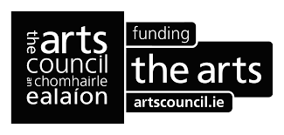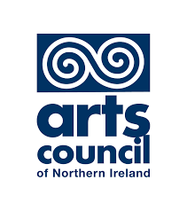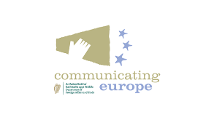

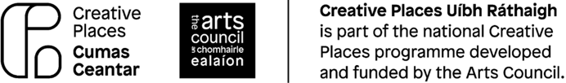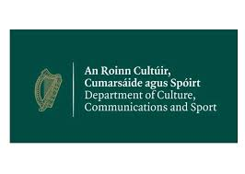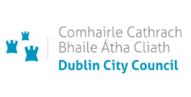

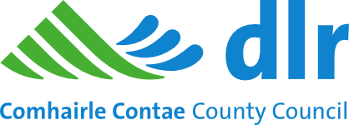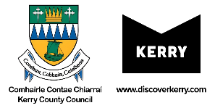

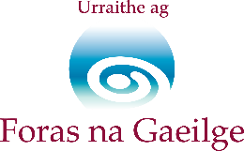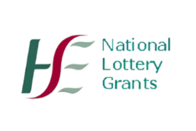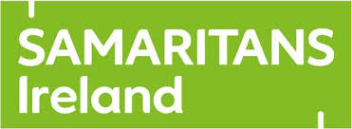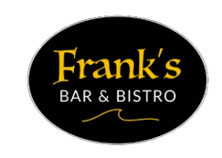

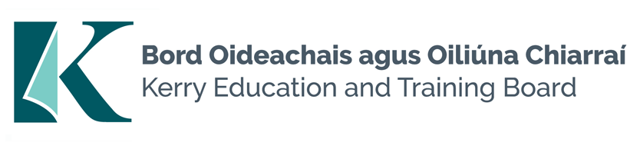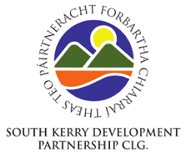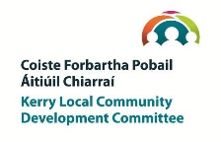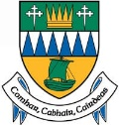
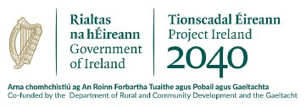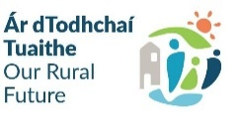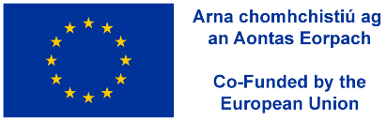

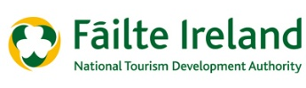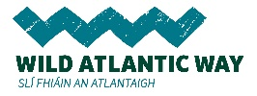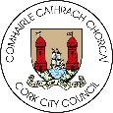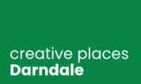

www.smashingtimes.ie

