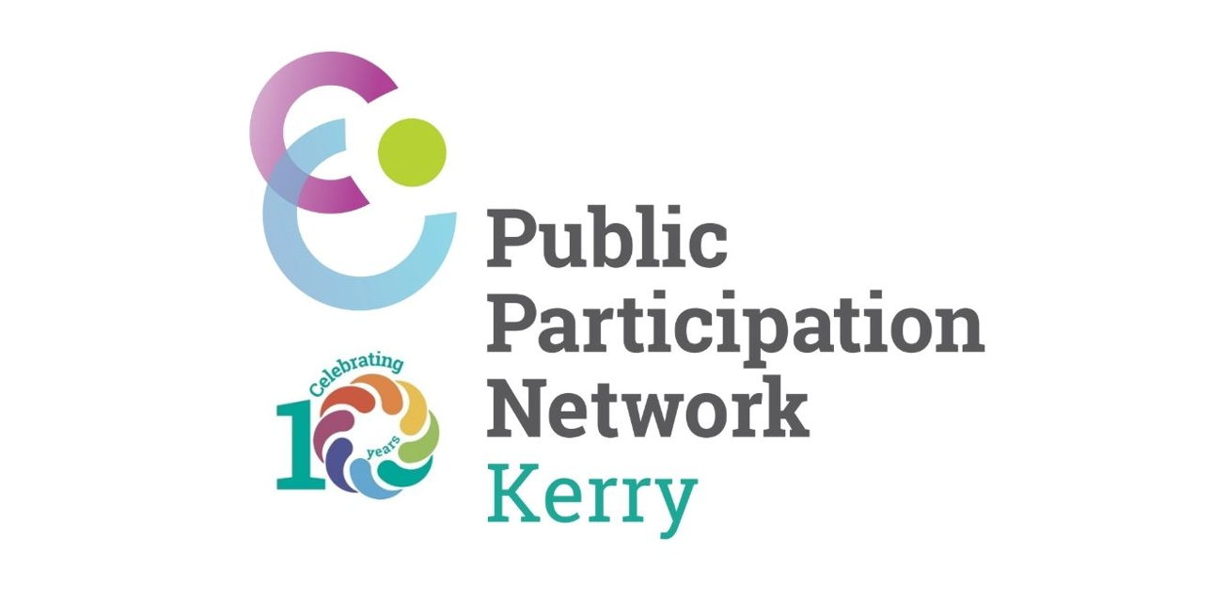

Monday 17th June 2024

Celebrating a Decade of Success:
Kerry Public Participation Network (PPN) Marks Its 10th Anniversary
#PPNcelebrating10years

The Kerry Public Participation Network (PPN) is delighted to announce the celebration of its 10th anniversary. This milestone marks a decade of significant achievements, growth, and unwavering commitment to enhancing community engagement and participation in County Kerry.

Since its inception in 2014, the Kerry PPN has served as a vital platform for community groups and organisations to engage with Kerry County Council, ensuring that the voices of the people are heard and considered in policy-making processes. Over the past ten years, the PPN has grown significantly, now representing over 1000 registered member groups which include community and voluntary, social inclusion and environmental groups throughout the county, reflecting the diverse and vibrant community spirit of Kerry.

Reflecting on a Decade of Achievements
As we celebrate this momentous occasion, we take pride in reflecting on the numerous accomplishments that have shaped the PPN into what it is today:
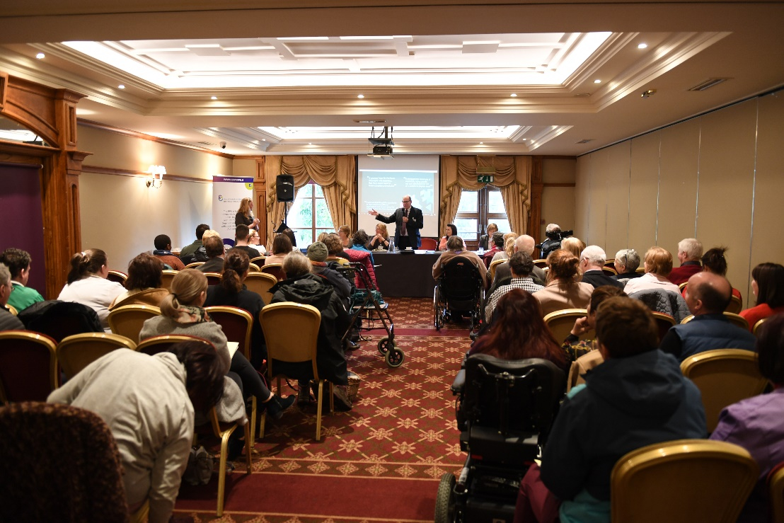
The Kerry PPN has facilitated hundreds of consultations, workshops, and public meetings, enabling community members to actively participate in decision-making processes. This has led to more inclusive and representative local policies.
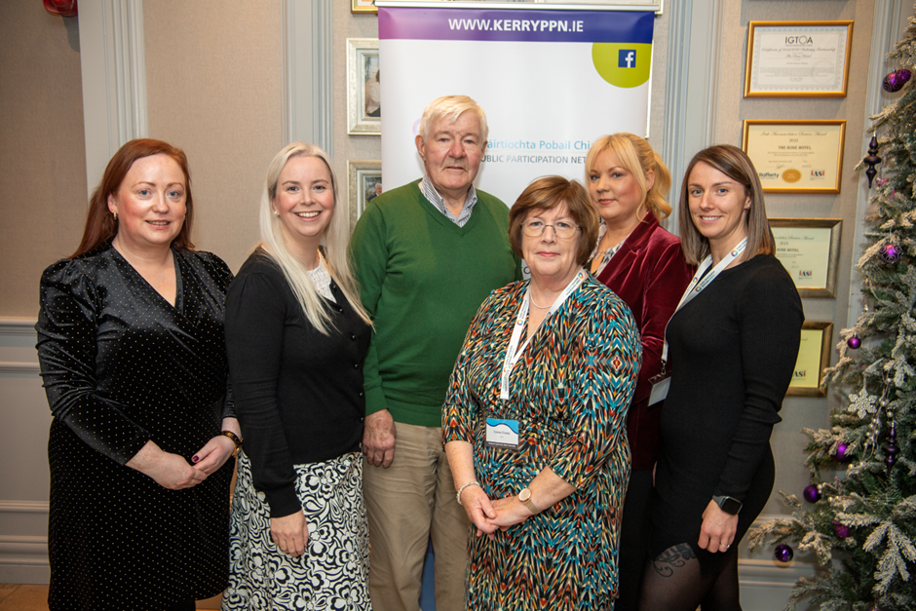
Through various training programmes, the Kerry PPN has empowered community groups with the skills and knowledge needed to effectively advocate for their needs, apply for various funding applications and build the capacity and resilience of their member groups. Topics covered include governance, funding applications, and strategic planning.
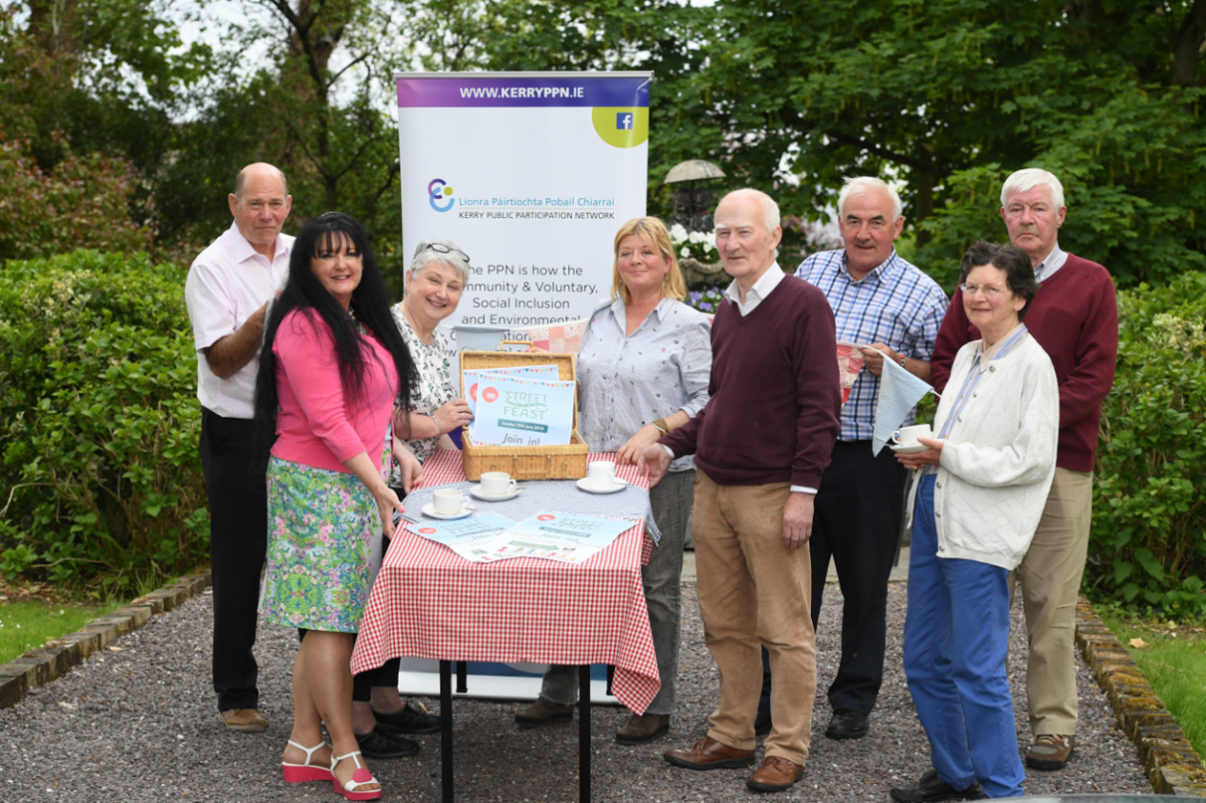

The PPN has been instrumental in several successful campaigns, including environmental initiatives, social inclusion projects, and the development of a community wellbeing vision for County Kerry. These initiatives have not only improved the quality of life in Kerry but have also fostered a strong sense of community.

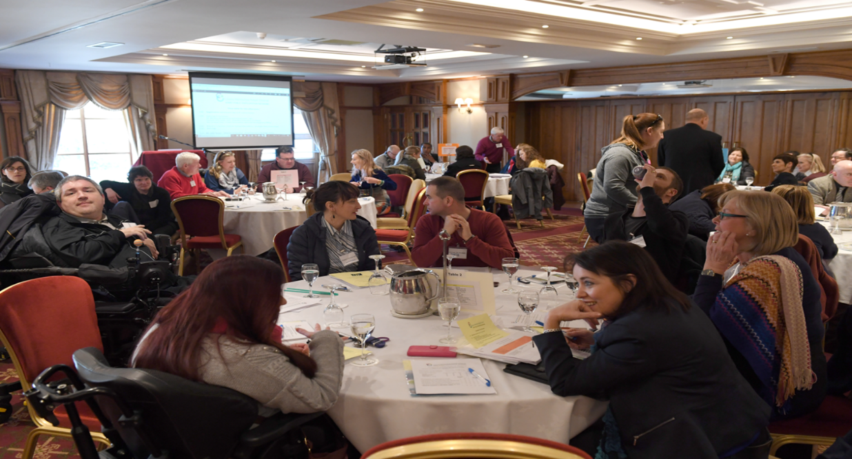

By providing a network for organisations to collaborate and share resources, the Kerry PPN has strengthened the community fabric of Kerry. This collaborative spirit has led to innovative solutions and successful partnerships that address local challenges.
The Kerry PPN’s dedication and impact have been recognised at both national and local levels. Various awards and accolades over the years are a testament to the hard work and commitment of its members and staff.
As we celebrate this 10-year milestone, we remain committed to our mission of fostering a vibrant, inclusive, and participatory community in Kerry. The coming years will see continued efforts to expand our reach, enhance our services, and adapt to the evolving needs of our community.
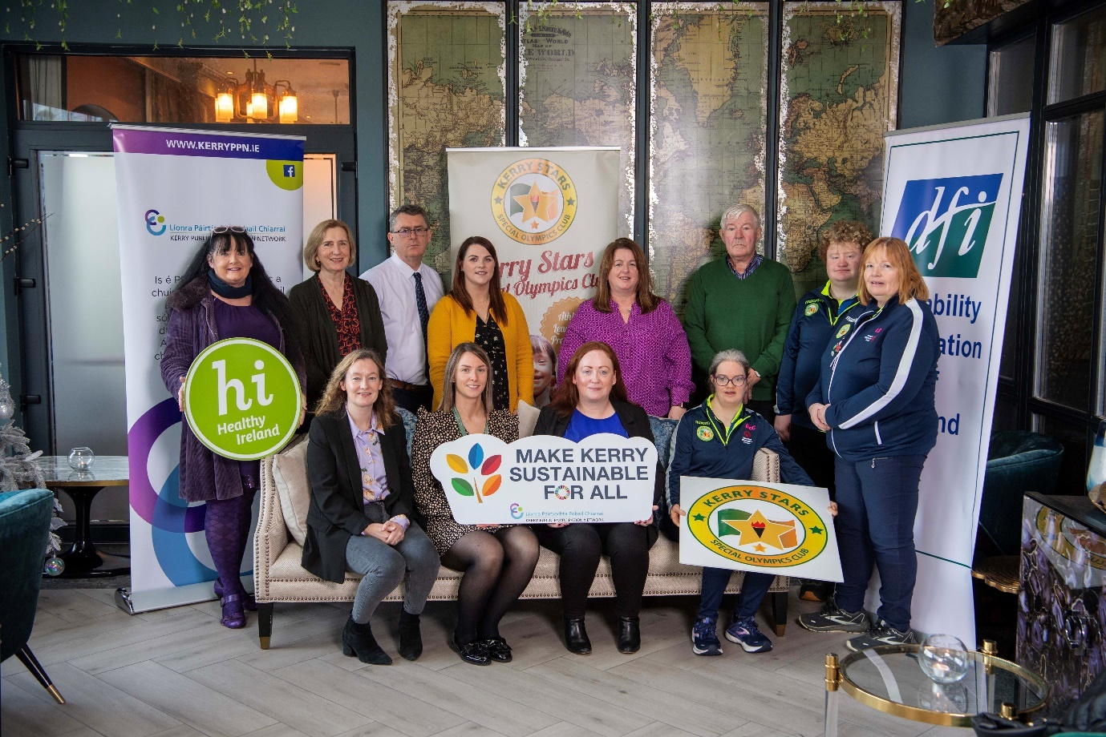

To commemorate this special occasion, the Kerry PPN will be hosting a series of events throughout the year, including information roadshows. We invite all our members and the wider community to join us in these celebrations and reflect on the collective achievements of the past decade. We would be delighted if groups would like to share photographs of their groups and the work that they are carrying out throughout County Kerry. For more information about the Kerry PPN, upcoming events, or to become a member, please visit the website at www.kerryppn.ie .
About Kerry PPN:
The Kerry Public Participation Network (PPN) is a collective network of community and voluntary groups, social inclusion organisations, and environmental groups in County Kerry. The PPN aims to empower and enable citizens to participate in local decision-making processes, ensuring a democratic and inclusive approach to local governance.

